Курсовая DWH

1. SQL-скрипт создания таблицы фактов и всех справочников

**CREATE** **TABLE** bookings.aircrafts_data (

aircraft_code **bpchar**(3) **NOT** **NULL**,

model **jsonb** **NOT** **NULL**,

"range" **int4** **NOT** **NULL**,

**CONSTRAINT** aircrafts_pkey **PRIMARY** **KEY** (aircraft_code),

**CONSTRAINT** aircrafts_range_check **CHECK** ((**range** > 0))

);

**CREATE** **TABLE** bookings.airports_data (

airport_code **bpchar**(3) **NOT** **NULL**,

airport_name **jsonb** **NOT** **NULL**,

city **jsonb** **NOT** **NULL**,

coordinates point **NOT** **NULL**,

timezone **text** **NOT** **NULL**,

**CONSTRAINT** airports_data_pkey **PRIMARY** **KEY** (airport_code)

);

**CREATE** **TABLE** bookings.boarding_passes (

ticket_no **bpchar**(13) **NOT** **NULL**,

flight_id **int4** **NOT** **NULL**,

boarding_no **int4** **NOT** **NULL**,

seat_no **varchar**(4) **NOT** **NULL**,

**CONSTRAINT** boarding_passes_flight_id_boarding_no_key **UNIQUE** (flight_id, boarding_no),

**CONSTRAINT** boarding_passes_flight_id_seat_no_key **UNIQUE** (flight_id, seat_no),

**CONSTRAINT** boarding_passes_pkey **PRIMARY** **KEY** (ticket_no, flight_id),

**CONSTRAINT** boarding_passes_ticket_no_fkey **FOREIGN** **KEY** (ticket_no,flight_id) **REFERENCES** bookings.ticket_flights(ticket_no,flight_id)

);

**CREATE** **TABLE** bookings.bookings (

book_ref **bpchar**(6) **NOT** **NULL**,

book_date **timestamptz** **NOT** **NULL**,

total_amount **numeric**(10, 2) **NOT** **NULL**,

**CONSTRAINT** bookings_pkey **PRIMARY** **KEY** (book_ref)

);

**CREATE** **TABLE** bookings.flights (

flight_id serial4 **NOT** **NULL**,

flight_no **bpchar**(6) **NOT** **NULL**,

scheduled_departure **timestamptz** **NOT** **NULL**,

scheduled_arrival **timestamptz** **NOT** **NULL**,

departure_airport **bpchar**(3) **NOT** **NULL**,

arrival_airport **bpchar**(3) **NOT** **NULL**,

status **varchar**(20) **NOT** **NULL**,

aircraft_code **bpchar**(3) **NOT** **NULL**,

actual_departure **timestamptz** **NULL**,

actual_arrival **timestamptz** **NULL**,

**CONSTRAINT** flights_check **CHECK** ((scheduled_arrival > scheduled_departure)),

**CONSTRAINT** flights_check1 **CHECK** (((actual_arrival **IS** **NULL**) **OR** ((actual_departure **IS** **NOT** **NULL**) **AND** (actual_arrival **IS** **NOT** **NULL**) **AND** (actual_arrival > actual_departure)))),

**CONSTRAINT** flights_flight_no_scheduled_departure_key **UNIQUE** (flight_no, scheduled_departure),

**CONSTRAINT** flights_pkey **PRIMARY** **KEY** (flight_id),

**CONSTRAINT** flights_status_check **CHECK** (((status)::**text** = **ANY** (**ARRAY**[('On Time'::**character** **varying**)::**text**, ('Delayed'::**character** **varying**)::**text**, ('Departed'::**character** **varying**)::**text**, ('Arrived'::**character** **varying**)::**text**, ('Scheduled'::**character** **varying**)::**text**, ('Cancelled'::**character** **varying**)::**text**]))),

**CONSTRAINT** flights_aircraft_code_fkey **FOREIGN** **KEY** (aircraft_code) **REFERENCES** bookings.aircrafts_data(aircraft_code),

**CONSTRAINT** flights_arrival_airport_fkey **FOREIGN** **KEY** (arrival_airport) **REFERENCES** bookings.airports_data(airport_code),

**CONSTRAINT** flights_departure_airport_fkey **FOREIGN** **KEY** (departure_airport) **REFERENCES** bookings.airports_data(airport_code)

);

**CREATE** **TABLE** bookings.seats (

aircraft_code **bpchar**(3) **NOT** **NULL**,

seat_no **varchar**(4) **NOT** **NULL**,

fare_conditions **varchar**(10) **NOT** **NULL**,

**CONSTRAINT** seats_fare_conditions_check **CHECK** (((fare_conditions)::**text** = **ANY** (**ARRAY**[('Economy'::**character** **varying**)::**text**, ('Comfort'::**character** **varying**)::**text**, ('Business'::**character** **varying**)::**text**]))),

**CONSTRAINT** seats_pkey **PRIMARY** **KEY** (aircraft_code, seat_no),

**CONSTRAINT** seats_aircraft_code_fkey **FOREIGN** **KEY** (aircraft_code) **REFERENCES** bookings.aircrafts_data(aircraft_code) **ON** **DELETE** **CASCADE**

);

**CREATE** **TABLE** bookings.ticket_flights (

ticket_no **bpchar**(13) **NOT** **NULL**,

flight_id **int4** **NOT** **NULL**,

fare_conditions **varchar**(10) **NOT** **NULL**,

amount **numeric**(10, 2) **NOT** **NULL**,

**CONSTRAINT** ticket_flights_amount_check **CHECK** ((amount >= (0)::**numeric**)),

**CONSTRAINT** ticket_flights_fare_conditions_check **CHECK** (((fare_conditions)::**text** = **ANY** (**ARRAY**[('Economy'::**character** **varying**)::**text**, ('Comfort'::**character** **varying**)::**text**, ('Business'::**character** **varying**)::**text**]))),

**CONSTRAINT** ticket_flights_pkey **PRIMARY** **KEY** (ticket_no, flight_id),

**CONSTRAINT** ticket_flights_flight_id_fkey **FOREIGN** **KEY** (flight_id) **REFERENCES** bookings.flights(flight_id),

**CONSTRAINT** ticket_flights_ticket_no_fkey **FOREIGN** **KEY** (ticket_no) **REFERENCES** bookings.tickets(ticket_no)

);

**CREATE** **TABLE** bookings.tickets (

ticket_no **bpchar**(13) **NOT** **NULL**,

book_ref **bpchar**(6) **NOT** **NULL**,

passenger_id **varchar**(20) **NOT** **NULL**,

passenger_name **text** **NOT** **NULL**,

contact_data **jsonb** **NULL**,

**CONSTRAINT** tickets_pkey **PRIMARY** **KEY** (ticket_no),

**CONSTRAINT** tickets_book_ref_fkey **FOREIGN** **KEY** (book_ref) **REFERENCES** bookings.bookings(book_ref)

);

**CREATE** **TABLE** bookings.dim_calendar (

"date" **date** **NOT** **NULL**

);

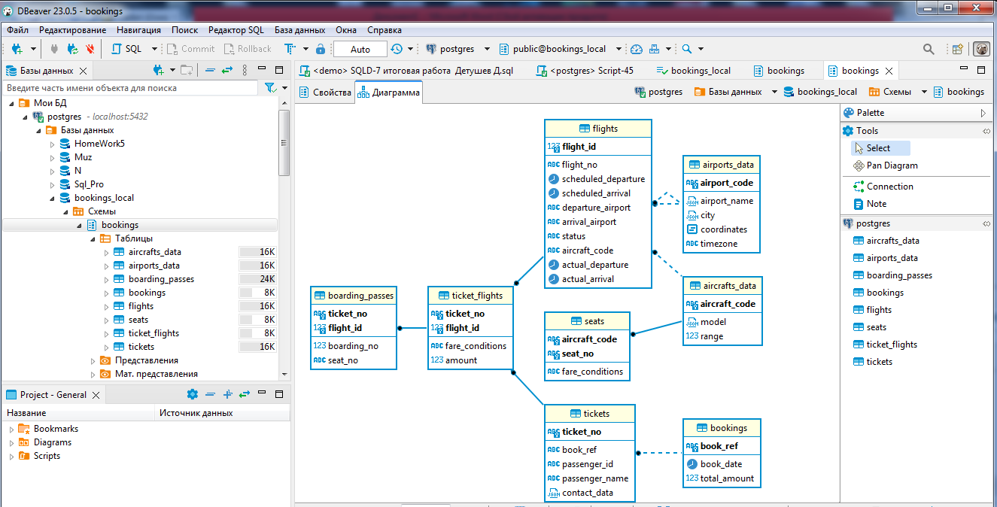

Диаграмма базы данных

--для создания колендаря дат создадим процедуру которая будет генерировать таблицу от заданной даты до текущей.

**create** **or** **replace** **procedure** insert_dim_calendar (date1 **date**) **as** **$$**

**declare**

i record;

date2 **date**;

**begin**

**for** i **in** (**select** **generate_series**(

(date1)

,('now ()')

, '1 day'::**interval**)::**date** **as** **date**)

**loop**

date2 = i.**date**;

**insert** **into** dim_calendar (**date**) **values** (date2);

**end** **loop**;

**end**;

**$$** **language** plpgsql

**call** insert_dim_calendar ('2020-01-01')

**CREATE** **TABLE** bookings.dim_passengers (

passenger_id **varchar**(30) **NOT** **NULL**,

passenger_name **varchar**(300) **NOT** **NULL**,

contact_data **varchar**(300) **NOT** **NULL**,

**CONSTRAINT** dim_passengers_pkey **PRIMARY** **KEY** (passenger_id)

);

**CREATE** **TABLE** bookings.dim_aircrafts (

aircraft_code **varchar**(3) **NOT** **NULL**,

model **varchar**(100) **NOT** **NULL**,

"range" **int4** **NOT** **NULL**,

**CONSTRAINT** dim_aircrafts_model_key **UNIQUE** (model),

**CONSTRAINT** dim_aircrafts_pkey **PRIMARY** **KEY** (aircraft_code),

**CONSTRAINT** dim_aircrafts_range_check **CHECK** ((**range** > 0))

);

**CREATE** **TABLE** bookings.dim_airports (

airport_code **varchar**(3) **NOT** **NULL**,

airport_name **varchar**(100) **NOT** **NULL**,

city **varchar**(100) **NOT** **NULL**,

timezone **varchar**(100) **NOT** **NULL**,

**CONSTRAINT** dim_airports_airport_name_key **UNIQUE** (airport_name),

**CONSTRAINT** dim_airports_pkey **PRIMARY** **KEY** (airport_code)

);

**CREATE** **TABLE** bookings.fact_flights (

passenger **varchar**(150) **NULL**,

date_dep **timestamp** **NULL**,

date_arr **timestamp** **NULL**,

diff_dep **varchar**(20) **NULL**,

diff_arr **varchar**(20) **NULL**,

model **text** **NULL**,

airport_dep **varchar**(50) **NULL**,

airport_arr **varchar**(50) **NULL**,

fare_condition **varchar**(20) **NULL**,

amount **numeric**(10, 2) **NULL**

);

**CREATE** **TABLE** bookings.dim_tariff (

id serial4 **NOT** **NULL**,

fare_conditions **varchar**(50) **NOT** **NULL**,

**CONSTRAINT** dim_tariff_fare_conditions_key **UNIQUE** (fare_conditions),

**CONSTRAINT** dim_tariff_pkey **PRIMARY** **KEY** (id)

);

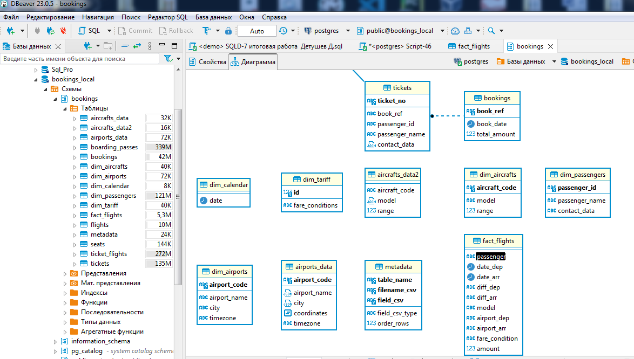Таблицы фактов и всех справочников

1. Трансформации

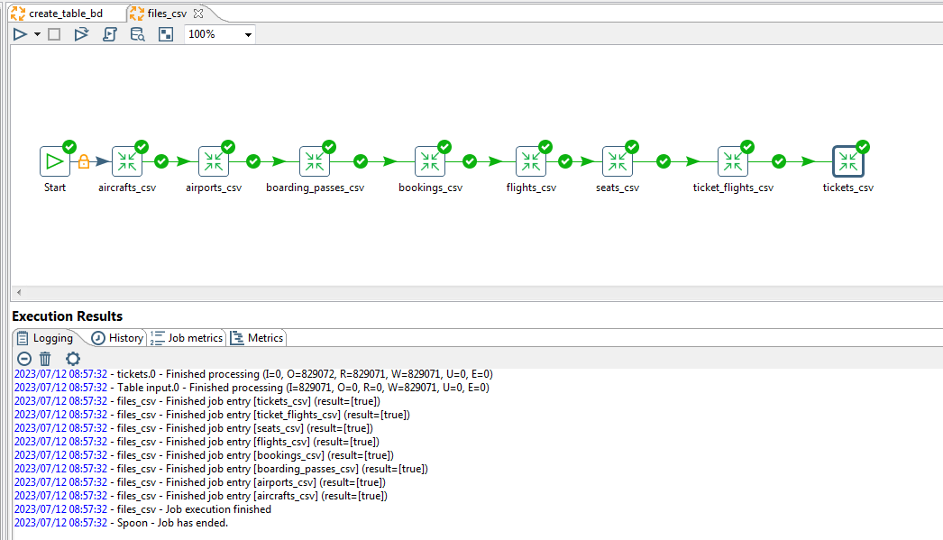

Работа с трансформациями сохранения таблиц с фактами и размерностями в csv файлы

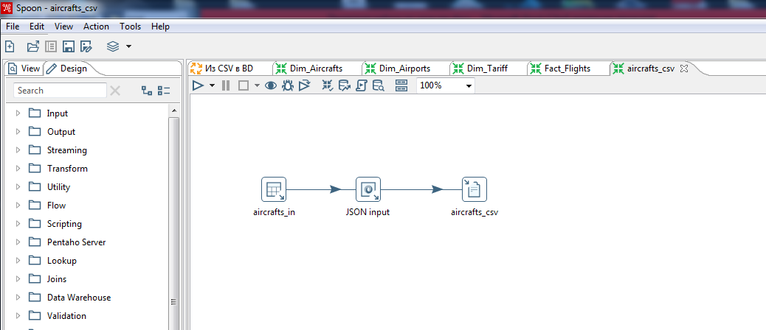

Трансформация на примере сохранения данных в файл aircrafts_csv

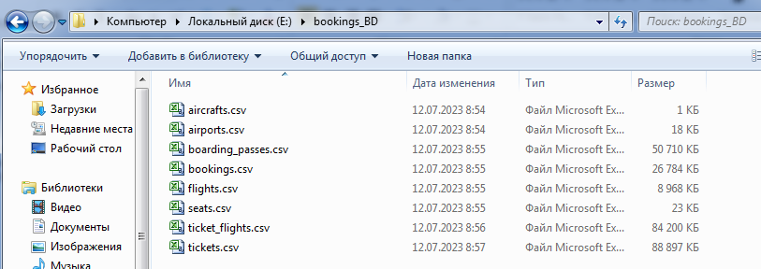

csv файлы

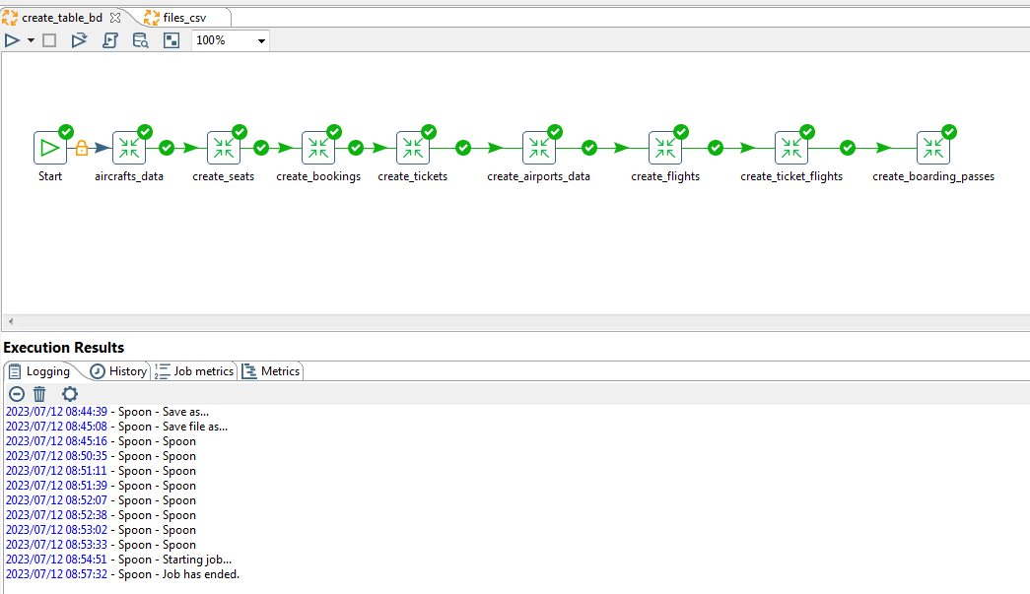

Работа с трансформациями создания таблиц базы данных

Для автоматизации процесса воспользуемся методом работы с метаданными. Для этого создадим необходимую таблицу

--Создание таблицы с метаданными

**CREATE** **TABLE** bookings."metadata" (

table_name **varchar**(20) **NOT** **NULL**,

filename_csv **varchar**(50) **NOT** **NULL**,

field_csv **varchar**(50) **NULL**,

field_csv_type **varchar**(20) **NULL**,

order_rows **int2** **NULL**,

**CONSTRAINT** csv_pkey **PRIMARY** **KEY** (table_name, filename_csv, field_csv)

);

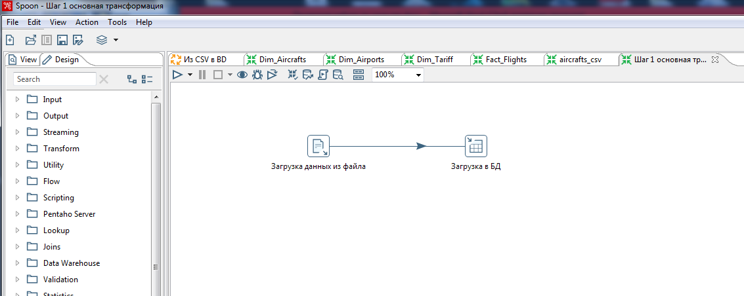

Основная трансформация

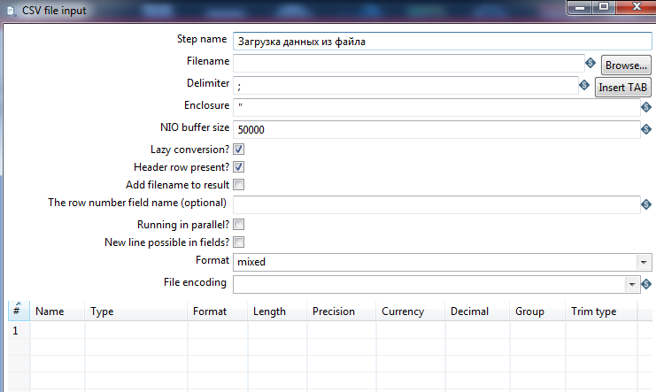

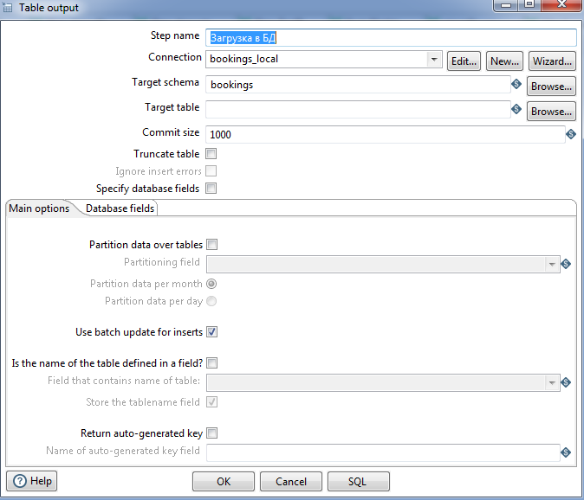

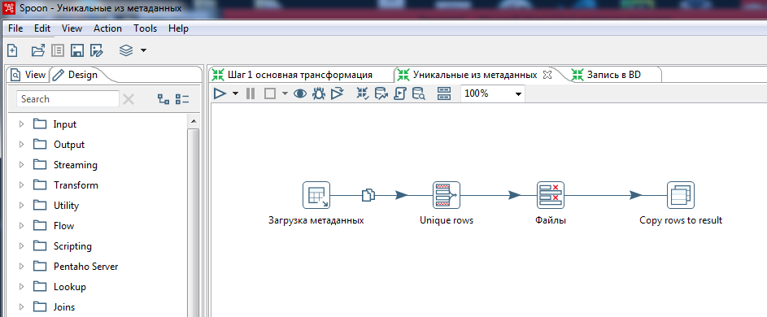

Уникальные из метаданных

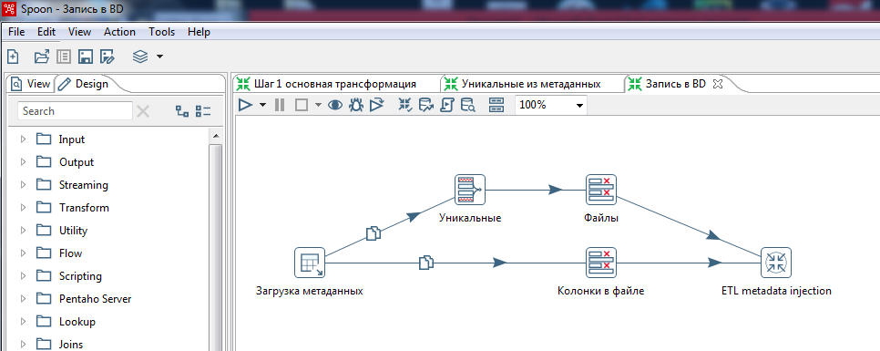

Запись в BD

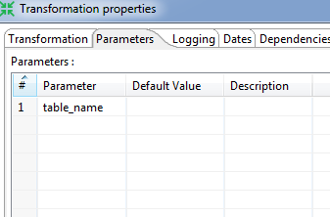

Для всех трансформаций созадим переменную table_name

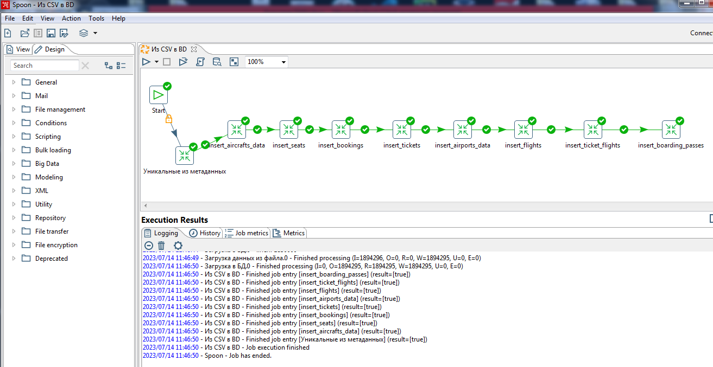

Работа с трансформациями сохранения данных в таблицы базы данных

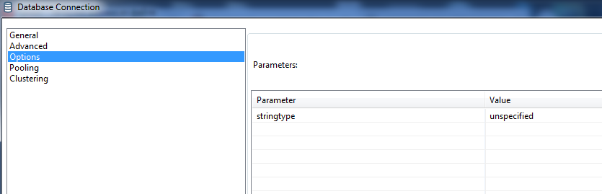

Для конвертации данных в тип JSON во вкладке опции установим параметр

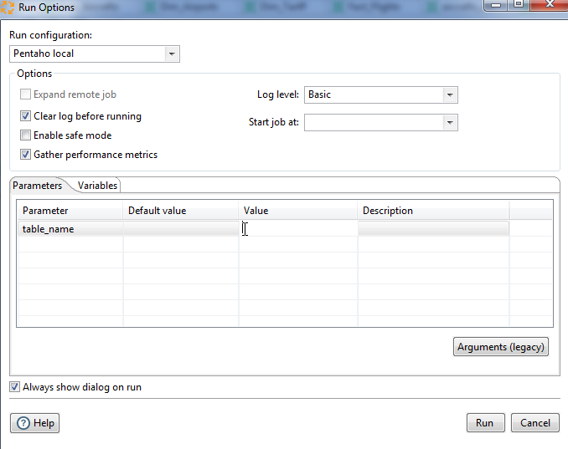

Теперь всё что нам нужно это при запуске работы записать наименование таблицы в базе данных в соответствии с очерёдностью

1. Трансформации сохранения данных в справочники

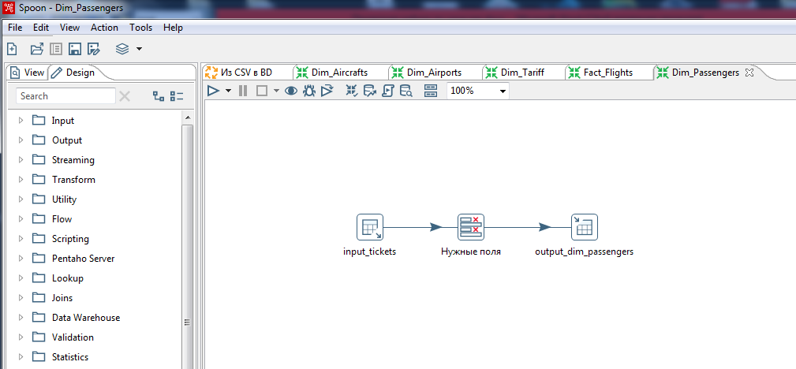

Dim_Passengers

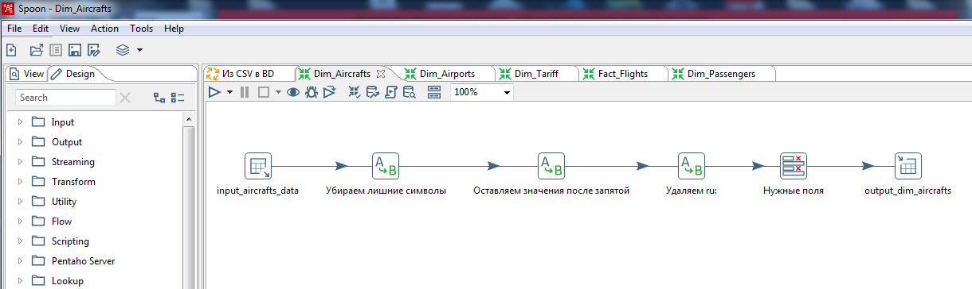

Dim_Aircrafts

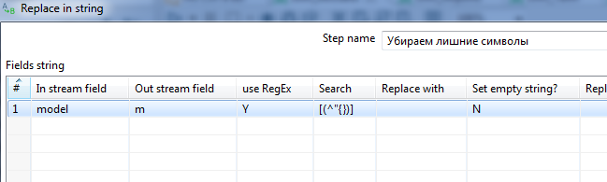

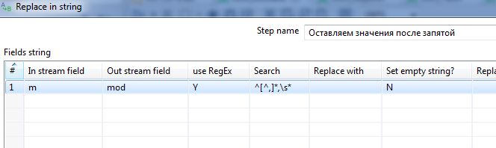

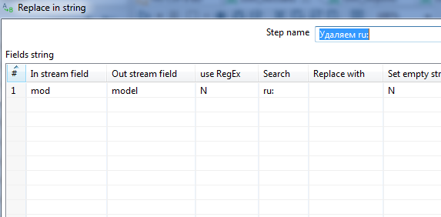

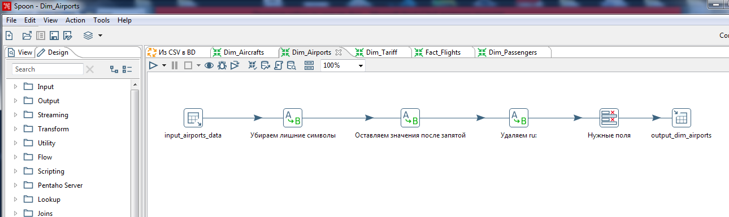

Dim_Airports

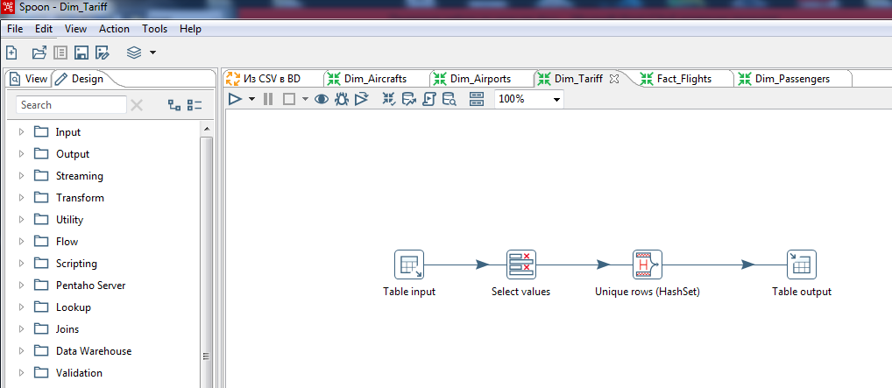

Dim_Tariff

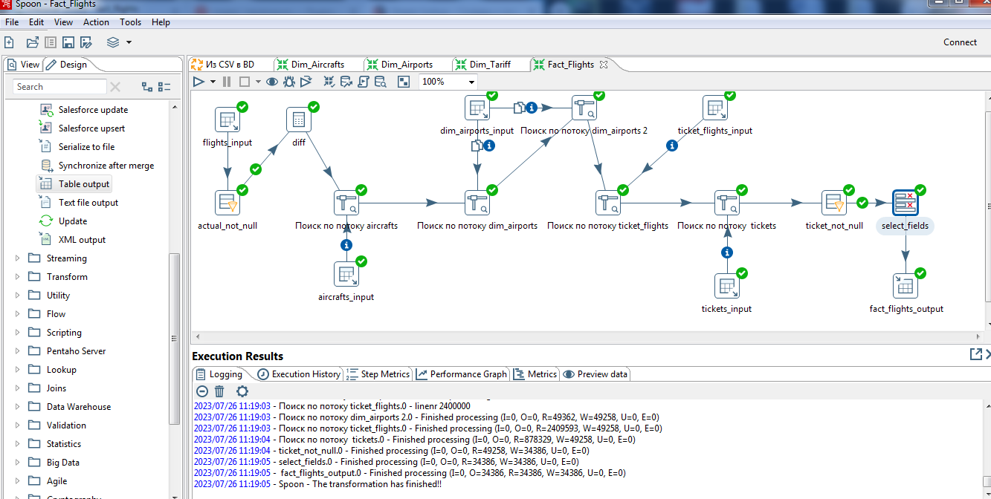

Fact_Flights

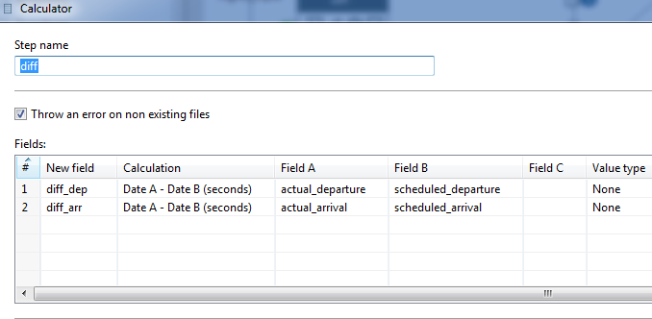

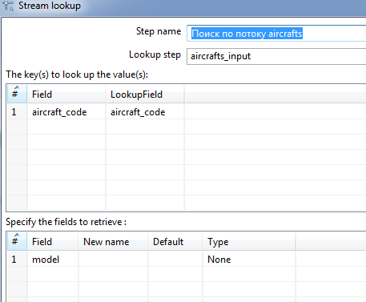



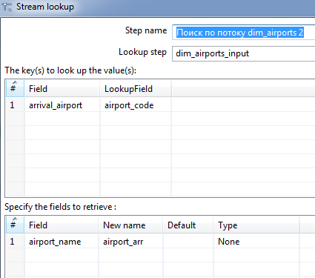

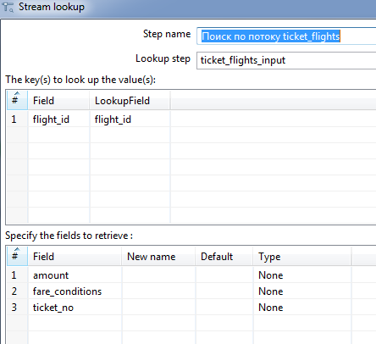

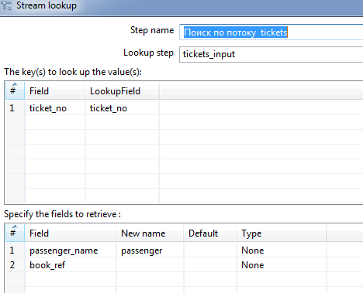

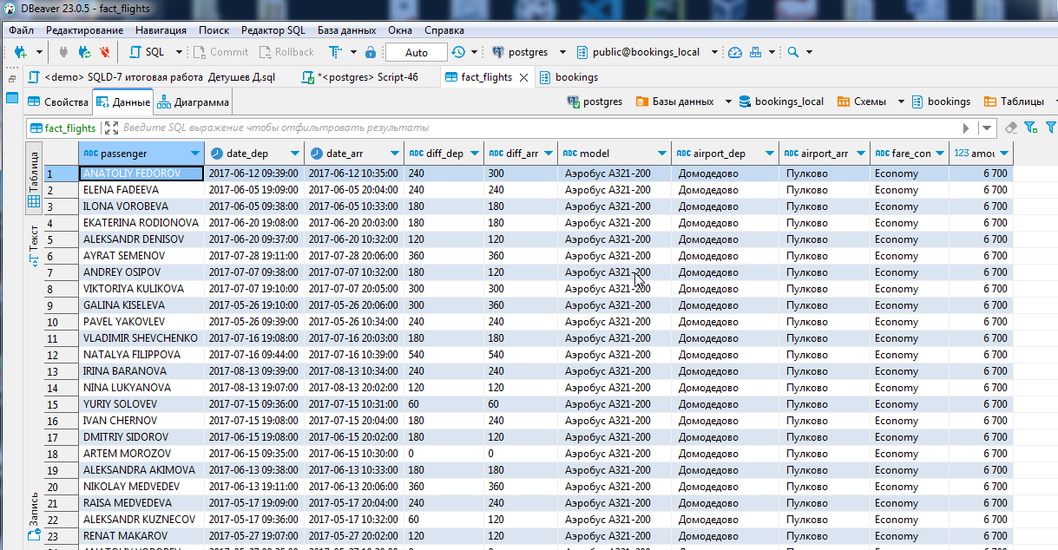

Данные в таблице Fact_Flights